EIHRA Certification
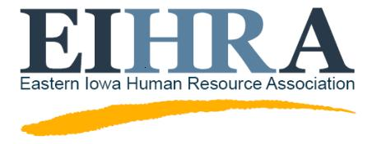
2017 Spring Study Group
Interest Form

Tuesdays February 21-April 25 5:30 pm-7:00 pm
Place: Circle Computer Resources, 845 Capital Dr SW, Cedar Rapids, IA
____________________________________________________________________________________________________________________________

E-mail completed form to Valerie Burns: vburns@ifpusa.com

Call: 319-721-8354 with any questions.

NOTE: You do not have to be a member of EIHRA to join the group and there is no charge to be a member of the study group.

Name _____________________________________________

Title _____________________________________________

Company _____________________________________________

Work Address _____________________________________________

Work Phone _____________________________________________

Cell Phone _____________________________________________

Fax _____________________________________________

E-mail _____________________________________________

Certification Level pursuing _______ SHRM-CP _______ SHRM-SCP

For the cost of the exam, to sign up and find a testing location, go to: www.shrmcertification.org.
Click on “Apply”.

Material cost is $525.00 (this is a discounted chapter price). You can reserve a copy using the Paypal link on the EIHRA website. EIHRA will order all the material on February 6th.

If you miss the above deadline, you may still join the study group but will be responsible for ordering your own material at the regular price. The website to order materials is: https://learningsystem.shrm.org/ls.html

